**Institute of Technology Tralee**

**BSc. in Computing with Specialism (Group 1) - Year 1**

**Continuous Assessment #1**

**Date: 23/10/13**

**Time: 3 – 5 p.m.**

**Introduction to Programming**

**Instructions:** Attempt the following question. You should use the JCreator IDE for coding. When you are finished you must print out your code for correction.

**________________________________________________________**

**Q1.**

In mathematics, it is possible to look at the slope (gradient) of 2 lines and determine a number of facts about them. If it turns out that the slopes are equal then the 2 lines must be parallel to one another. If the slope of one line multiplied by the slope of the other equals -1 then the lines must be at right angles (perpendicular) to one another. If neither of these two cases are true then the lines intersect but are not perpendicular to each other.

Also, if the slope of a line equals zero then that line must be parallel to the x-axis.

Write a Java program that first of all prompts for and reads in the slopes of 2 lines (these slopes may be fractional values). The program should then perform some tests on the slopes of the lines as indicated above and display some results based on these tests.

Using the test values as indicated in the screen shots below, the program should give you **exactly** the following output when it runs, including any banners, blank lines etc.

Also note that there will be a few marks awarded for the use of **meaningful variable names**, having a **single and multi-line comment at the top of the program** and for **proper indentation** in the coding of the program.

**Sample Screen Shots**

**The user enters slope values of 1.5 and 3.3**

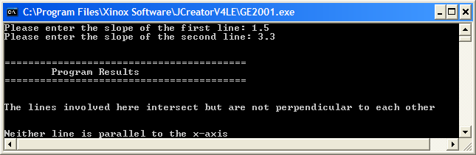

**The user enters slope values of 0.2 and -5**

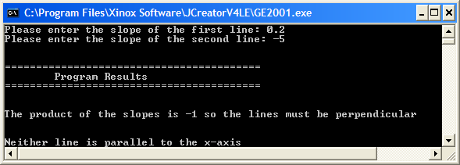

**The user enters slope values of 4.5 and 4.5**

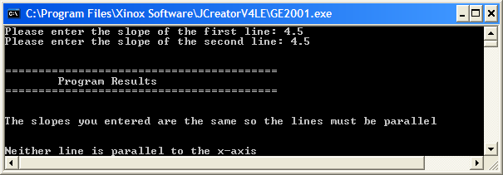

**The user enters slope values of 4.5 and 0**

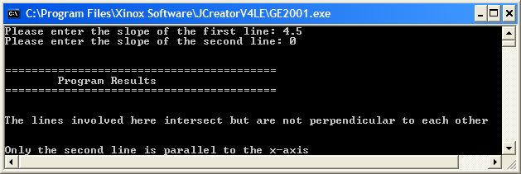

**The user enters slope values of 0 and 0**

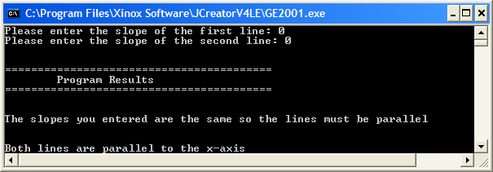

**The user enters slope values of 0 and 8.7**

